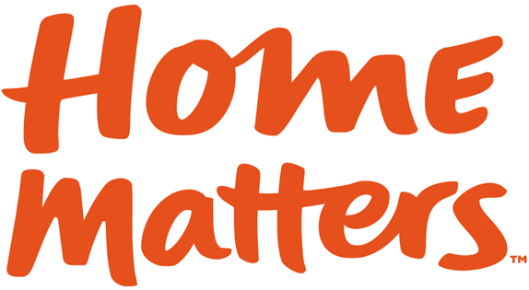

News Release

Contact:
Pat Swanson, U.S. Bank Corporate Communications
(816) 871-2394, patrick.swanson@usbank.com

U.S. BANK AND HOME MATTERS PARTNER WITH JESSE DYLAN’S WONDROS
FOR VIDEO SERIES ON THE IMPROTANCE OF “HOME”

WASHINGTON, D.C. (June 15, 2015) – Home Matters, the national movement focused on raising awareness and funds to make “Home” a reality for all, is partnering with U.S. Bank to launch an engaging video series to be crafted by Jesse Dylan’s creative firm Wondros about the importance of access to safe, stable housing and communities

“The Home Matters movement was launched two years ago to change the way people think about where they live,” said Dave Brown, CEO of Home Matters. “There are many quality of life issues – from health to education and financial success to public safety – which all have Home as a common denominator. With these next videos, we’ll get everyday Americans talking about where they live and how important it is that every American lives in a safe and nurturing environment.”

U.S. Bank donated $75,000 to fund a video series to be produced by Wondros in the coming months. Wondros will work with Home Matters and U.S. Bank to develop a creative approach to talking about why where people live is so important.

“Wondros sets out to help translate the issues and encourage an audience to ask the underlying questions about a cause. The changing landscape of housing in our country is a fascinating topic, and we look forward to working with Home Matters and U.S. Bank to dig deeper,” said Jesse Dylan, founder, creative director and chief executive officer of Wondros.

Wondros has worked with some of the world’s leading nonprofit organizations to develop compelling videos and campaigns, including The Open Society Foundations, TED, MD Anderson and ONE, among many others.

“We hope that our support of Home Matters encourages conversations about the importance of Home, and having Wondros on board will go a long way toward building awareness of the cause,” said Melissa Borino, director of community development for U.S. Bank. “U.S. Bank is committed to helping families and individuals gain access to Home by providing financial education, working with first-time homebuyers and supporting the development of affordable rental housing in communities across the country.”

Last year U.S. Bank committed approximately $7 billion in tax-credit equity and construction loans to support the development of affordable rental housing nationwide, including projects with units specialized for homeless, veterans and senior citizens, among other groups. The bank also offers online financial education and specialized mortgage programs for first-time homebuyers.

The John D. and Catherine T. MacArthur Foundation has provided funding support for the video series. The Foundation released a survey last week which found that over half of all U.S. adults (55%) have had to make at least one sacrifice in order to cover their rent or mortgage. Such sacrifices include getting an additional job, deferring saving for retirement, cutting back on health care and healthy foods, running up credit card debt, or moving to a less safe neighborhood or one with worse schools.

About Home Matters
About Home Matters® The Home Matters® (www.HomeMattersAmerica.com) movement was launched in 2013 by a group of visionary housing professionals and leaders that identified a gap in public discourse. Fundamental social challenges in our nation – from health to education, to public safety, the economy and individual success – all have a common denominator: their connection to Home. With a high-level, holistic approach to housing, Home Matters underlines the link between Home and these core societal issues such as health, education, safety, individual success and the economy.
About U.S. Bank
U.S. Bancorp (NYSE: USB), with $410 billion in assets as of March 31, 2015, is the parent company of U.S. Bank National Association, the 5th largest commercial bank in the United States. The Company operates 3,172 banking offices in 25 states and 5,016 ATMs and provides a comprehensive line of banking, brokerage, insurance, investment, mortgage, trust and payment services products to consumers, businesses and institutions. Visit U.S. Bancorp on the web at usbank.com.

# # #

